THE NATIONAL INSTITUTE OF ENGINEERING

(Autonomous Institute under VTU, Belagavi) Mysuru – 570 008

Seminar Report on

**SMARTPHONE PROCESSORS**

## Submitted in partial fulfillment of the requirement for the award of degree of Bachelor of Engineering in

**Electrical & Electronics Engineering**

## Prepared by:

## Ravi N

## VII Semester

Under the Guidance of:

**Ms. Ashwini G**

## Assistant Professor

**Department of Electrical & Electronics Engineering The National Institute of Engineering**

(Autonomous Institute under VTU, Belagavi) Mysuru – 570 008

### 2022-23

**Assessment Sheet**

Seminar title: SMARTPHONE PROCESSORS

Date of Presentation:12/1/23

Name of the student with USN Signature of the student

Name of the Course Instructor: Comments of the Course Instructor:

Signature of Course Instructor

### DEPARTMENT OF ELECTRICAL & ELECTRONICS ENGINEERING

### THE NATIONAL INSTITUTE OF ENGINEERING

(An Autonomous Institute under VTU, Belagavi

Recognised by AICTE, New Delhi, Grant-in-Aid by Government of Karnataka, Accredited by NAAC, New Delhi)

Manandavadi Road, Mysuru- 570 008.

Phone: 0821-2480475, 2481220, 4004900 Fax: 0821-2485802, E-mail: [principal@nie.ac.in](mailto:principal@nie.ac.in) Website: [www.nie.ac.in](http://www.nie.ac.in/)

**CERTIFICATE**

*Certified that this seminar report entitled* **“*SMARTPHONE PROCESSORS*”** *is a bonafide work carried out by* ***Mr. Ravi N (4NI19EE082),*** *under the guidance of* ***Ms. ASHWINI G,*** *in partial fulfilment for the award of the degree of Bachelor of Engineering Electrical and Electronics Engineering at The National Institute of Engineering (Autonomous Institute under VTU) during the academic year 2020-2021.*

**Ms. Ashwini G**

Assistant Professor,

Department of E &EE

The National Institute of Engineering Mysuru

### Dr. H Pradeepa

HoD, Department of E &EE The National Institute of Engineering Mysuru



### Dr. Rohini Nagapadma

### Principal

The National Institute of Engineering Mysuru

### Name of the examiners Signature with date

1.

2.

**ACKNOWLEDGEMENT**

I would like to express my sincere gratitude to Ms. Ashwini G for providing invaluable guidance, comments, and suggestions throughout the course of the seminar. I would also like to express my profound thanks to all those who have indirectly guided and helped me in the preparation of this seminar.

I also express my heartfelt gratitude to our Head of the department, Dr. Pradeepa H for providing me with all the facilities and permission to do this Seminar.

I consider myself privileged to have studied in esteemed institution, THE NATIONAL INSTITUTE OF ENGINEERING, Mysuru. Lastly, I would like to thank all the faculty and staff members of the Department of electrical and electronics Engineering, Mysuru. I would also like to thank my parents for their moral support and encouragement.

**ABSTRACT**

Cell phones have become a necessity for many people throughout the world. The ability to keep in touch with family, business associates, and access to email are only a few of the reasons for the increasing importance of cell phones. However, the mobile-phones in early times were bulky, restrictive to only some features and worked only in areas where there was a good connection. All these problems were resolved by integrating a processor within a cell-phone. The processor is the central hub of your smartphone. It receives and executes every command, performing billions of calculations per second. The effectiveness of the processor directly affects every application you run, whether it's the camera, the music player, or just a simple email program. In the following journal, we have discussed the distinctive features, merits, and demerits of the latest mobile phone processors of different Tech companies.

This seminar report explains, the smartphone processor market is growing at a great pace with an increase in the efficiency and optimization of the Processors is discussed and comparison of the single-chipsets.

Now a day’s smart phones have developed into sophisticated gadgets, they are offering numerous prospects. They are just like super computers. The core processor is the brain of the smart phone operations. In mobile, multi core processors are needed to handle multiple applications. A processor executes the instructions provided by the users. They supports real time applications and artificial related applications because of its LTE Modems, which supports high data rates. In this paper, super smart processors namely Qualcomm Snapdragon Processor family features and its LTE Modems of each of these are compared and discussed.

This information would be of great help to all those who are keen to know about the specifications of each processor in detail.

**CONTENTS**

**Chapter 1: Introduction.**

* 1. Processors 8
  2. Smartphone Processors… 8
  3. Literature Survey… ……………………………………………9-10
  4. Need For advancement ………………………………………..11-12

Chapter 2: Processors Specifications……………………………..13

* 1. Construction of Processors 14
  2. Architecture of Processors……………………………………….15
  3. Cores ……………………………………………………………...16
  4. Clock speed ……………………………………………………….17
  5. Nanometer Technology …………………………………………...17
  6. Different Processors in Market …………………………………...18-19

Chapter 3: Conclusion………………………………………………..20

* 1. Future Scope ………………………………………………………21
  2. References …………………………………………………………22

**List of Figures**

Fig 1. Smartphone Processor chip 12

Fig 2. Traditional DSP Architecture (Harvard Architecture) 15

Fig 3. Comparison of Quad and Octa core 16

Fig 4. Smartphone Processors Ranking………………………………………………………18

# Processors:

1. **INTRODUCTION**

a processor or processing unit is an electrical component (digital circuit) that performs operations on an external data source, usually memory or some other data stream. It typically takes the form of a microprocessor, which can be implemented on a single metal–oxide–semiconductor integrated circuit chip. In the past, processors were constructed using multiple individual vacuum tubes, multiple individual transistors, or multiple integrated circuits. Today, processors use built-in transistors.

The term is frequently used to refer to the central processing unit (CPU) in a system. However, it can also refer to other coprocessors, such as a graphics processing unit (GPU).

# Smartphone Processors:

A mobile processor is found in mobile computers and cell phones.

A CPU chip is designed for portable computers to run fan less, under 10-15W, which is cool enough without a fan. It is typically housed in a smaller chip package, but more importantly, in order to run cooler, it uses lower voltages than its desktop counterpart and has more sleep mode capability. A mobile processor can be throttled down to different power levels or sections of the chip can be turned off entirely when not in use. Further, the clock frequency may be stepped down under low processor loads. This stepping down conserves power and prolongs battery life.

The performance of your smartphone is influenced largely responsible for the speed, efficiency and battery life of your smartphone—the processor.

This is the “brain” of the smartphone. The CPU receives commands, makes instant calculations and sends signals throughout your device.

There are multiple ways to gauge the performance of a CPU besides checking the Gigahertz (GHz) speed or the number of CPU cores (a.k.a dual-core and quad-core and octa-core).

# LITERATURE SURVEY

|  |  |  |  |
| --- | --- | --- | --- |
| **SI NO** | **Title of Paper** | **Author name and year of Publication** | **Summary** |
| 1 | Processors for mobile applications | Koushanfar, Farinaz & Prabhu, Vandana & Potkonjak, Miodrag & Rabaey (2020) | * Mobile processors form a large and very fast-growing segment of semiconductor market. * the processors for use in mobile applications possess a number of distinct characteristics * getting a high-end processor, means investing in an expensive flagship smartphone |
| 2 | A Comparative Study on the Recent Smart Mobile Phone Processors | P. Surana, N. Madhani and T. Gopalakrishnan (2020) | * The Application processor block executes the user’s application software * every processor is independentof itself as far as the architecture is concerned * Improv Systems provides a programmable platform for a multi-processor implementation of a configurable datapath. |
| 3 | An Analysis of Power Consumption in a Smartphone | Aaron Carroll, Gernot Heiser (2019) | * analyse the energy usage and battery lifetime under a number of usage patterns * calculate the power consumed by any processor, both the supply voltage and current must be determined * enable a systematic approach to improving power management of mobile devices. |

|  |  |  |  |  |  |
| --- | --- | --- | --- | --- | --- |
|  | [4] | Evolution of Processor Architecture in Mobile Phones | Mahendra Pratap Singh, Manoj Kumar (2018). | * The design and deployment of mobile processors over the years is largely affected by Communication, performance, and low-power operation. * There have been two distinct approaches for implementation of cellular handsets. One approach emphasizes programmable DSP’s, while the other approach utilizes ASIC (Application-specific integrated circuit) techniques * Multiply-accumulate (MAC)instructions are commonly associated with DSP architectures |  |
| [5] | Comparison of Mobile Phone Processor’s Architecture | Qurat Ul Ain, Aqsa Saddique, Iqra Tariq  (2018) | * Smartphones are increasingly ubiquitous, and many users carry multiple phones to accommodate work, personal, and geographic mobility needs * Cells introduces a usage model of having one foreground virtual phone and multiple background virtual phones. * Demonstrate that Cells imposes only modest runtime and memory overhead, works seamlessly across multiple hardware devices |
| Page **10** of **22** | | | | | |

# Need For advancement:

* + - **5G Price Point Expansion**: Each cellular network technology transition brings new opportunities, market participants and challenges and stretches the pie available to all stakeholders. The current boom in mobile processor markets is undoubtedly driven by 5G. 5G, introduced first 2019, took off rapidly and is growing faster than 4G did in the initial years. To spread new network technology benefits, ecosystem vendors usually push the technology to lower price tiers to accelerate the adoption. 5G is precisely at that point now and 2021 and 2022 will see a massive push from the ecosystem in terms of price point expansion. Qualcomm and MediaTek will play a pivotal role in this and are well-positioned to capture 5G share.
    - **Non-handset Revenue**: Smartphones represent a big chunk of the cellular-enabled devices market but there is a growing demand for non-handset cellular devices. Qualcomm is investing in ADAS, Edge AI, infrastructure SoC, Windows on Arm and server CPUs.
    - **Transistor Technology Advancements**: Thanks to pandemic-driven demand, foundries are struggling to meet the demand in 5G, consumer electronics, automotive and other areas. **TSMC** and **Samsung Foundry** continue to push the envelope with their process technology with advanced offerings such as 5 nm EUV. We expect 3 nm-based smartphone chips to debut in 2H 2022 and 2 nm-based chips to debut in 2H 2023.
    - **Performance Gains:**The smartphone SoC market continues to witness impressive performance gains across CPU, GPU, AI, modem and transistor technology enhancements each year. We still see over 20 percent CPU and over 30 percent GPU performance gains.

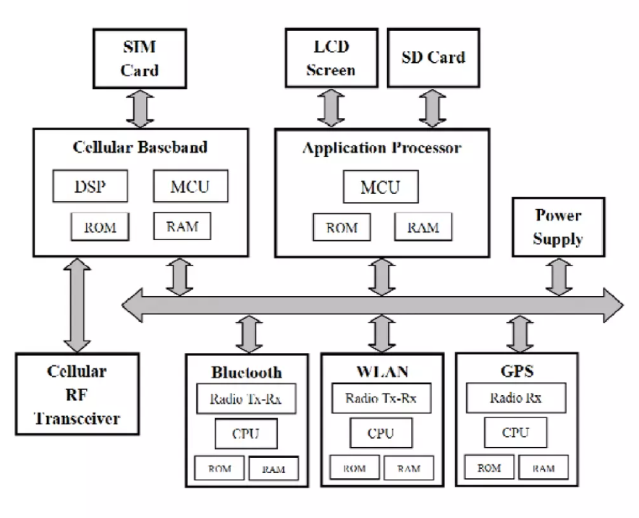Fig 1. Smartphone Processor chip

* **Memory Parameter**: RAM is a super-fast type of storage which is faster than your phone’s main storage where your apps, photos, videos, and music get stored, and it helps your smartphone work and feel fast. This is all the more paramount during multitasking and switching between apps. If a phone is said to multitask well, it’s because it has heaps of RAM and is able to make good use of it. Today, most users prefer 6-8 GB RAM phones which give them a fluid experience. For hard-core gamers, a 12GB RAM would be ideal since it will be able to handle all types of heavy games seamlessly.

1. **PROCESSORS SPECIFICATIONS**

With the advancement of computer technology, the number of specifications for each component in a computer has become overwhelming for those not deeply involved in the computer industry. We often get questions such as “what does the frequency mean?” or “are more CPU cores always better?” In this article, we will explain the major specifications for CPUs and what they mean for the end user.

## **Code Name:** The code name of a CPU is what further divides a product line. When a new advancement is made to the basic architecture of a CPU line, it is given a new code name.

## **Socket**: e socket name doesn’t give you any information as to the actual specification of the socket.

## **Process:** Smaller manufacturing processes give two major benefits: First, a smaller process means that more components can fit within a certain space. This is why CPUs today are much smaller than they were several years ago, yet are much more powerful. Second, a CPU will run cooler and require less wattage with a smaller manufacturing process.

## **Number of Cores:** it was found that a single core could no longer handle the workload which resulted in the CPU becoming a bottleneck. The solution was simple: add more cores! Each core is basically a whole new processor, so by adding a second core the power of the CPU was essentially doubled. While multiple cores almost immediately had an impact on multitasking, multiple cores were inefficient at first at powering high-load applications.

## **2.1 Construction of Smartphone processors:**

processors are manufactured primarily from silicon, the second most common element on the planet (only the element oxygen is more common). Silicon is the primary ingredient in beach sand; however, in that form it isn’t pure enough to be used in chips.

The manner in which silicon is formed into chips is a lengthy process that starts by growing pure silicon crystals via what is called the Czochralski method (named after the inventor of the process). In this method, electric arc furnaces transform the raw materials (primarily quartz rock that is mined) into metallurgical-grade silicon. Then to further weed out impurities, the silicon is converted to a liquid, distilled, and then redeposited in the form of semiconductor-grade rods, which are 99.999999% pure. These rods are then mechanically broken up into chunks and packed into quartz crucibles, which are loaded into electric crystal pulling ovens. There the silicon chunks are melted at more than 2,500° Fahrenheit. To prevent impurities, the ovens usually are mounted on very thick concrete cubes—often on a suspension to prevent any vibration, which would damage the crystal as it forms.

After the silicon is melted, a small seed crystal is inserted into the molten silicon and slowly rotated (see [Figure 3.3](javascript:popUp('/content/images/chap3_0789734044/elementLinks/03fig03.gif'))). As the seed is pulled out of the molten silicon, some of the silicon sticks to the seed and hardens in the same crystal structure as the seed. By carefully controlling the pulling speed (10–40 millimeters per hour) and temperature (approximately 2,500°F), the crystal grows with a narrow neck that then widens into the full desired diameter. Depending on the chips being made, each ingot is 200mm (approximately 8") or 300mm (12”) in diameter and more than 5 feet long, weighing hundreds of pounds.

The ingot is then ground into a perfect 200mm- (8”) or 300mm-diameter (12”) cylinder, with a small, flat cut on one side for positioning accuracy and handling. Each ingot is then cut with a high-precision diamond saw into more than a thousand circular wafers, each less than a millimetre thick. Each wafer is then polished to a mirror-smooth surface. Chips are manufactured from the wafers using a process called photolithography. Through this photographic process, transistors and circuit and signal pathways are created in semiconductors by depositing different layers of various materials on the chip, one after the other. Where two specific circuits intersect, a transistor or switch can be formed.

**2.2 Architecture of Processors:**

1. **Traditional DSP (Digital Signal Processor) Architectures:**

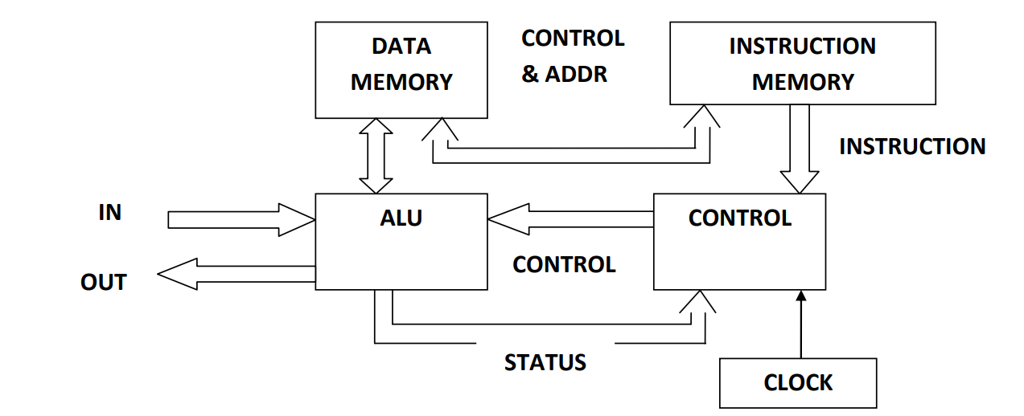Traditionally, DSP used Harvard architecture which physically separates storage and signal pathway for instructions and data [2]. This is in contrast with Von Neumann Architecture, where data and instructions are stored in the same memory. As shown in Figure 2, it requires data memory and instruction memory to execute instructions. It has separate data and instruction buses allowing simultaneous transmission. Subsequently, the output of multiplication unit connects to an adder, thereby adding and saving all partial results for further processing.

Fig 2. Traditional DSP Architecture (Harvard Architecture)

1. **Modern DSP Architectures:** Apart from traditional architectures, some modern DSP architectures have evolved for mobile devices. TMS320C55 is a modern DSP architecture which implements Harvard architecture utilizing one and three read buses for code and data
2. **System on Chip (SoC) based architectures:** Mobile device processor architecture became simple with SOC designs. Real time responsiveness in mobile devices can be managed by using an enhanced DSP hybrid chip. Lowering the voltage of the chip enables low power operation in mobile devices.
   1. **Cores:**

A smartphone CPU core is an individual processing unit found on the central processing unit (CPU) of a mobile phone. It is responsible for receiving and executing instructions that are sent from the user to the phone. The core is responsible for making sure that all the tasks and instructions are carried out correctly and as quickly as possible. The speed at which the CPU core can execute instructions (also known as the clock speed) is measured in cycles per second and expressed in gigahertz (GHz). The higher the clock speed, the faster the core. So, a 2.4GHz CPU core is faster than a 1.8GHz CPU core.

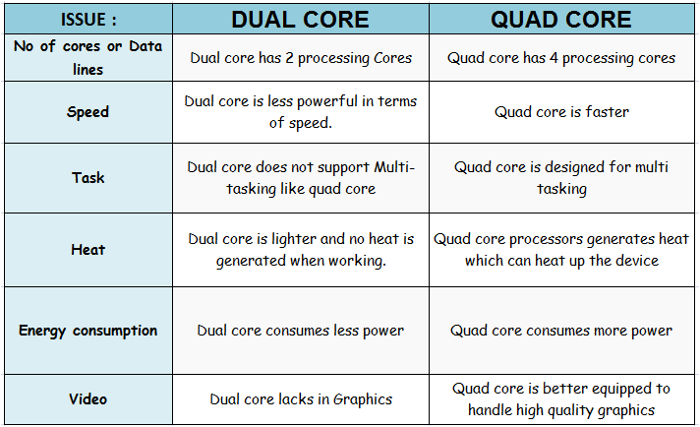Fig 3. Comparison of Quad and Octa core

**2.4 Clock speed:**

The performance of your CPU—the “brain” of your PC—has a major impact on the speed at which programs load and how smoothly they run. However, there are a few different ways to measure processor performance. Clock speed (also “clock rate” or “frequency”) is one of the most significant. The clock speed determines how many instructions the processor can execute per second.

A processor with a 1-Gigahertz (GHz) clock speed can process 1 billion instructions per second. The general rule is that higher clock speeds make for faster phones. user can often see this with more expensive smartphones. Their processor cores have higher clock speeds than those of more affordable devices. The number of processor cores also influences the speed of the smartphone.

**2.5 Nanometer Technology:**

**nm**stands for Nanometer. nm is a unit of measurement for length in a metrics system just like meters, centimeters, etc. It is used to express dimensions on the atomic scale. In technical terms, it is referred to as "**process node**" and "**technology node**". CPUs are made up of billions of transistors and are housed in a single chip. The smaller the distance between transistors in the processor (in nm), the more transistors can fit in a given space. As a result, the distance traveled by electrons to perform useful work is reduced. This ultimately results in faster computing power, less energy consumption and heat dissipation, less thermal output around the board, and smaller die size, which ultimately reduces costs and increases transistor density of the same size, resulting in more cores per chip. Intel currently employs 10nm or 14nm technology, while TSMC employs 7nm technology. These are the processor's lithography.

Lower nm has following advantages:

* **More Power Efficient:** a lower nm transistor means there is less power required for it to work. When you look at all the transistors in a CPU, lower power consumption makes a processor more power-efficient compared to a higher nm processor.
* **Less Cooling Required**: when the transistors in your CPU consume less power, less heat is generated overall.
* **Transistors Are Faster:** When the transistor size is smaller, there is less distance between them. Less distance means the electric signal will travel faster, making the overall performance of the CPU faster.

**2.6 Different Processors in Market:**

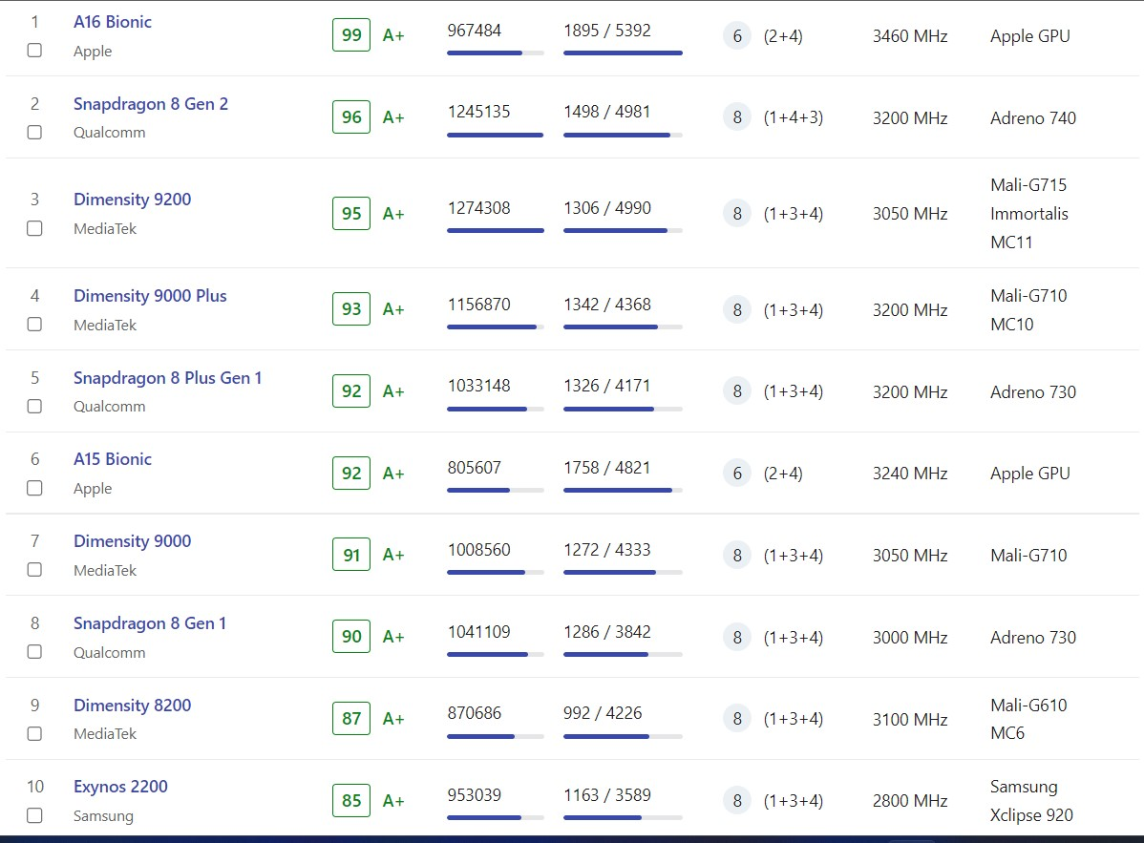

Fig 4. Smartphone Processors Ranking

1. **Apple bionic chips:**

* The Apple A16 Bionic features an Apple-designed 64-bit six-core CPU implementing ARMv8.6-A.  with two "Everest" high-performance cores running at 3.46 GHz
* The A16 contains 16 billion transistors, a 6.7 % increase from the A15's transistor count of 15 billion.
* this used in the iPhone 14 Pro and 14 Pro Max models only.

1. **Qualcomm snapdragon processors:**

* Qualcomm Snapdragon 8 Gen 2 – an 8-core chipset that was announced on November 15, 2022, and is manufactured using a 4-nanometer process technology
* The Snapdragon 8 Gen 2 Mobile Platform is latest premium-tier powerhouse.
* This is the company’s front runner and that which will power most of the flagships of 2023.
* Some of the smartphones which use this processor are Vivo X90 Pro Plus, OnePlus 11 and Motorola Moto X40 etc

1. **MediaTek Dimensity:**

* The top mobile chip in MediaTek's stable is described as a "milestone of innovation," and that "everything inside its super powerful—yet super power efficient—4nm package screams flagship chip."
* The Dimensity 9200 delivers a sizable 35 percent performance advantage over other Android flagships, and is reportedly 37 percent more power efficient too.
* Some of the smartphones which use this processor are Vivo X90 Pro 5G, OnePlus Nord 5 and Vivo S17 Pro etc

1. **EXYNOS:**

* The Samsung Exynos 2200  is a high end SoC with 8 cores in three clusters.
* Samsung Exynos 2200 – an 8-core chipset that was announced on January 18, 2022, and is manufactured using a 4-nanometer process technology.
* Some of the smartphones which use this processor are **Samsung Galaxy S22 Ultra, Samsung Galaxy S22+ and Samsung Galaxy S22**

1. **CONCLUSION**

Processors have a major role to play in any device with its various components for processing and executing instructions. The latest processors are coming up with a greater efficiency The technology advancement expects to build up the more power proficient versatile processor designs for portable devices. Processors have a major role to play in any device with its various components for processing and executing instructions. We see that the people of this generation are willing to buy anything that goes with today's trend and sacrificing on the actual needs that a smart-phone should provide them daily. This makes the smartphone to be of no specific use for them thus making it worthless. Through this review paper we have provided the information to the public about various smart-phone companies and the unique processors integrated in them which is in turn directly proportional to the mode of their use. The latest processors are coming up with a greater efficiency but no novelty in comparison to its preceding ones. We as users expect the processors to come up with better technologies and distinctive features. This would require an innovative and enthusiastic mind to deliver better ideas. Through this journal we are trying our level best to enlighten the minds from all walks of life.

**3.1 Future scope:**

The processor is a system consisting of a chip that can offer better assistance in the operating system of smartphones. The application processor addition in the mobile industry is growing at a faster pace. There are many advantages of smartphone processors. The smartphone performance is at the best level if the application processor is used. These days, there are many smart devices which are available for the use of the consumer. Smartphones, tablets, reader devices, navigation devices and gaming consoles to name some are the variations in the market of the Smartphone application process. The processor also lets such devices use any specific operating system type.

There are iOS, Android, and other windows operating systems which are used in popularity. There are more processor capabilities. It helps to enhance the decoding and also the graphics controller. The processor is the 8th generation technology which comes with a good innovation. The tech consumer base is also growing at an exponential rate. It thus leads to more development in the market of the Smartphone application processor. These days, many mobile phones are coming up with advanced processors. The top mobile manufacturers are developing the smartphone application processor. The smartphone experience of the customer is also increasing because of the advanced processor use. All such factors would increase the market value of the smartphone application processor.

In the coming time, there will be more demand for the Octa-core processor chips. It would increase the smartphone application processor market rate while the supply, purchase and demand of smartphones would increase in the coming years. All such factors are beneficial for the market of the smartphone application processor.  Also, the rate of expansion is likely to reach the peak that shall bring favorable changes.

# 3.2 References:

|  |  |
| --- | --- |
| [1] | Koushanfar, Farinaz & Prabhu, Vandana & Potkonjak, Miodrag & Rabaey, J.M.. (2020). “Processors for mobile applications”. 603-608. 10.1109/ICCD.2000.878354. |
| [2] | P. Surana, N. Madhani and T. Gopalakrishnan, "A Comparative Study on the Recent Smart Mobile Phone Processors," 2020 7th International Conference on Smart Structures and Systems (ICSSS), Chennai, India, 2020, pp. 1-3, doi: 10.1109/ICSSS49621.2020.9202174. |
| [3] | Carroll, Aaron & Heiser, Gernot. (2019). “An Analysis of Power Consumption in a Smartphone”. Proc. 2010 USENIX conf., USENIX Assoc.. |
| [4] | PratapSingh, Mahendra & Kumar, Manoj. (2018). “Evolution of Processor Architecture in Mobile Phones”. International Journal of Computer Applications. 90. 10.5120/15564-4339. |
| [5] | Ain, Qurat Ul & Saddique, Aqsa & Tariq, Iqra & Maqsood, Talal & Ishaq, Iqra & Zafar, Shaista & Malik, Babur. (2018). “Comparison of Mobile Phone Proceessor's Architecture”. 970-973. 10.1109/ICSESS.2018.8663778. |